Business Requirements Document (Task 1)

[NZ AT a Glance](http://127.0.0.1:8000/)

We provide the list of the best New Zealand tours

Team: Demi Albuquerque and Paula da Silva

**Task 1: Team Organization**

**Team Contract**

* The Team Contract was created at the first day of the Project. Before we started the project, we agreed with the terms and conditions of the contract and after reviewing it we both signed it.

**Collaboration Tools**

* To communicate to each other and keep record of the team decisions we decided to use the Teams Chat.
* To Stores shared project documentation, we created a Teams Group called App security and server-side development Project where we both can edit the document.

Also, we made available all the shared files needed for the actual project inside Team so we both have access to it.

* The shared code will be stored at GitHub folder.
* To plan the project, we decided to use the Microsoft Office Planner. With this board we can schedule, assign, coordinate and keep track of our tasks.

**Stand-up Meetings**

* We will hold a 30 min daily meeting to discuss the project tasks and deliverables.

Each day a different Team Member will run the meeting with the objective to discuss the tasks completed since the last meeting and the ones schedule for the next one. Also, we can discuss unresolved issues that are preventing or slowing down the project.

We will record the meetings data in a Meeting Minutes and update the MSO Planner according with it.

Team Process Self-Evaluation at the end of the documentation with the minutes and additional evidences required.

**Task 2: Reflective Journal (Individual)**

**Paula – Individual Journal**

Summary of Personal Contributions

All contributions done towards the project was equally divide and worked out through the project together. We had planned and structured the project together.

I had been designed to focus more towards the Architecture of our web application coding, testing and making sure all the user stories was achieved as per the requirements, while my business partner was doing the documentation. Once each step was completed, we had the task to review each other's work and contribute with ideas for improvement.

The Implementation process was very smooth as we have been testing and working on the bugs all the way through, the web application documentation was revised and tested by us both to minimize any errors and unexpected security issues.

Overall this project is more a combination of contributions than individual contributions as such.

Evidences attached at end of the project documentation

**Demi – Individual Journal**

**Summary of Personal Contributions**

As a team we decide from the beginner to make decisions together, we both had a leadership role for the project and discussed each other ideas than decided what was best for the project.

We planned from the beginner that Paula was going to be more involved in the code development and I would do the documentation helping each other when necessary.

I was responsible for the business and solutions requirements, analyzing the problem that we had and the best way to provide a solution for it.

**Design Commentary**

In the security area I provided the idea to lock the user account if they provide credentials that do not match the ones in the database and the only people able to unlock it need to have administrator credentials.

**Implementation**

We implemented restricted users and employees' permissions for specific areas of the website to prevent error and crashes. We tested this implementation and it was successfully achieved.

**Code Review**

The code follows the best practice to be simple and easy to understand.

**Testing Commentary**

We tested each employee and user access restriction and we got no bugs. Everything was working as planned.

Please find team contribution proves attached at end of the project documentation.

**Task 3: Requirements Analysis & Planning**

**Business Requirements**

Problem Overview

Introduction

The web application needs to be created and managed to supply and facilitate the high demand for the “NZ AT a Glance” tourism company in New Zealand.

The web application must streamline the data access, restrict the user's access and maximize the security of the company and client's data.

Always having in mind that security it is a continuous process that requires constant assessment to reduce the overall risk.

Statement of Problem or Need

The problem presented are cyber-attacks increasing exponentially making security the number one priority for companies to continue delivering the services and keeping the worldwide clients thrust.

If a website is hacked and blacklisted, it can result in lawsuits, heavy fines, and ruined reputation.

A proposed solution to reduce those attacks is to apply security principles from the beginner to the web applications.

We propose to develop our security policies by implementing the CIA triad, – Confidentiality, Integrity and Availability and use those on the ongoing process that is to manage the website.

Business Requirements

List of stakeholders for our software company

* Website owner
* Customers and viewers who access the website
* Credit card company who manages and authorizes customer payments
* Account system team
* Investors who provide funding
* Shareholders who manage and run the business
* Advertisement company who markets the company
* DevOps Team who develops and operate the websites
* Management team

Client

Demi Albuquerque and Paula Martinho representing the stakeholders.

List of business requirements

**Current business processes for the “NZ AT a Glance” web site**

• Customers and viewers - are able to login to website and see the agent names, tour available and durations.

• Administrator - look after the web site. Can create new users following the Username and password Guideline. Also, they should have permissions to add, modify and delete records from all the tables and manage website users and permissions

• Agents – they provide their personal information and information on the tours they conduct. Have permissions to add a tour and modify tours that they conduct.

• Management – Able to see all the tour and agent information. Also, able to remove agents from the list and modify all the tour information.

* Website store customer’s details
* Provide a web interface (mobile, desktop, tablet) to enable customers and employees to see available tours.
* Provide a system easy to use and apply appropriate user interface design principles.
* Record sales and payments details in accounting system.

Quality requirements

Portability Requirements

Usability Requirements

Security Requirements

Certification

Availability

Business Solution

Options considered

**Option 1:**

Choose a website host with features like web application firewall (WAF) and denial-of-service (DDoS) protection to ensure you will built a safe website.

Choose a good and friendly content management system (CMS) as it is a [useful tool to construct website](https://www.webfx.com/cms.htm)s and manage future content, keep in mind the most beneficial ones are continually advancing their protections.

Allow the website to have some add-on and plugin but with Periodic inspection to reduce the likelihood of defective extras. Also, we can use add-ons for our benefit like the ones that limit viruses.

Restrict users and employees permissions for specific areas of the website to prevent error and crashes.

User names and password must follow the guideline documentation and if it is possible implement Two-factor authentication to increase login security.

Set up safe automatic backups even if it is more expensive, it can keep you from starting from scratch.

Include a secure sockets layer certificate (SSL) to guard online purchases. Also, exchange an HTTP address for HTTPS. This address improves your site’s security and serves as a trust signal to customers and business partners, which is critical.

**Option 2:**

Choose a website host with features just like web application firewall (WAF) but not (DDoS) protection to save some money.

Choose a good content management system (CMS) but do not worry too much about their continually advancing protection as you will use just as a tool to construct the website.

Do not allow the website to have plugins and add-ons as it just slow down the website and impede responsiveness.

Restrict users and employees permissions for specific areas of the website to prevent error.

User names and password must have a few rules but we do not need to follow any guideline documentation.

Set up automatic backups if does not cost too much.

Include a secure sockets layer certificate (SSL) to guard online purchases.

**Option 3:**

Choose the cheapest website host and content management system (CMS) you can find, there are good ones that are not too expensive.

Allow the website to have many plugins and add-ons to enhance the experience for customers.

Apply access restriction to customers but do not worry about the employee’s access restrictions as they will not do something to harm their own company.

User can choose the best user name and password as they find fit and easy to remember otherwise they need to change passwords all the time.

For small websites do not worry about the backups as they are expensive.

**Evaluation Criteria**

* Cost
* Benefits

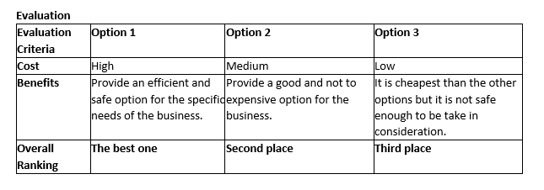

Recommended Solution

**Business Solution outline**

**Solution position statement:**

*For companies that security is the number one priority and want to have a system that is secure and efficient at same time we offer the first option for the business solution.*

*The solution is more expensive than the other but take in consideration security since the beginner of the website creation and continue through the management of the same.*

Main Features

* Secure and efficient website
* Restrict access.
* System is easy to use and will apply appropriate user interface design principles.

**Unique value proposition / Justification**

What makes your recommended solution unique? Why do you recommend this one?

* Our solution is unique because our team have highly technical skills in the security field.

* The objective of our solution is to continue delivering efficient services and keeping the worldwide clients thrust by creating a website that is secure and reliable, that is way we choose the option one even if it is more expensive.

Solution Requirements and Scope

Function Requirements

**Context Diagram**

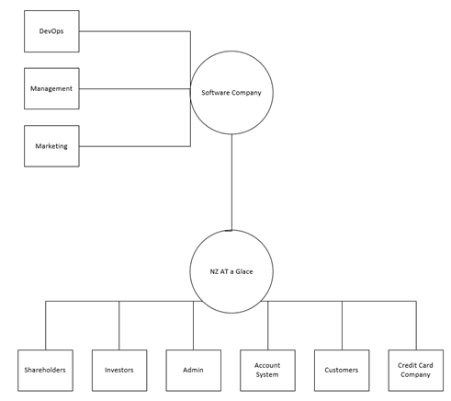

User roles for the “NZ AT a Glance” web site:

* Visitor
* Customer
* Investors
* Credit card company
* Advertise company
* Account system
* Shareholders
* Contractor software company

**Business Domain Model**

Entity Relationship Diagram

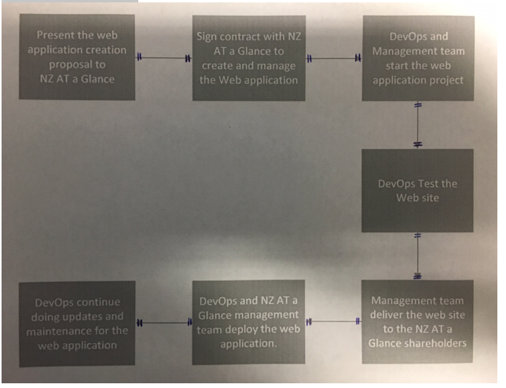

Description or Definition of each entity

**User Stories**

User stories in the scope for the first release:

The core user stories are:

· As a user I would like to be able to use the web application from multiple devices.

· As a user I would like to book the tour online.

Supporting user stories for the first release:

· As a user I would like to have a user account to access the application features.

· As a shareholder I want to create weekly development and production internal reports.

· As a shareholder I want to manage online bookings.

· As an Administrator I want to have permissions to add, modify and delete records from all tables.

· As an Administrator I want to manage the web application users and permissions.

· As an Agent I want to update my personal information.

· As an Agent I would like to add and modify my tours.

· As a Manager I would like to see all the tours and agent information.

· As a Manager I would like to remove agent.

· As a Manager I would like to modify all tour information.

**List of non-functional requirements**

**Non-Functional Requirements**

**Portability Requirements -** Accessibility and responsiveness of our service across different platforms one of our priorities.

**Usability Requirements -** Our Website will be built with ease of use in mind. This will be designed intuitively to allow easy navigation for users and employees which will be reflected in our wireframe designs.

**Security Requirements -** The system needs to protect both the user and the environment from harm. Some security features include:

* Authenticate all staff users
* Data Integrity
* Data Confidentiality
* Data Confidentiality
* Secure payment process
* Protect the system from common security treats and attacks.
* Implement an effective multi-factor authentication for the user login.
* The fail logins are registered and monitored with a limit number of attempts so if the user exceed it the account is automatically locked.

Certification

The *NZ AT a Glance* website will comply with all industry standards and regulatory agencies. On a constant basis we will also endeavour to keep our consumers informed of any changes within our service and terms of conditions.

**Out of scope:**

**Availability -** The website must be available to users 24/7.

**Backlog**

Product Backlog

These are requirements that are not included in this release but will be included in subsequent releases.

User stories

The following user stories are out of scope of the first release:

· As a shareholder I want to create weekly development and production internal reports.

· As an accountant I want to have access to accurate monthly financial reports.

· As an administrator I want to create weekly development and production internal reports.

**Task 4: Solution Design**

**System Design Document**

Project: NZ AT a Glance

By: Demi Albuquerque and Paula Martinho

# **Architecture**

# **Web Framework**

*Django framework explanation:*

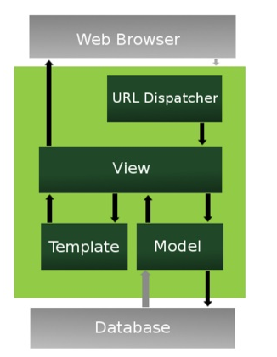

Django web applications group the code that handles each of these steps into separate files:

**URL Dispatcher**: it maps the requested URL to a view function and calls it. A URL mapper is used to redirect HTTP requests to the view based on the request URL.

**View:** Perform the requested actions, usually reading or writing to the database but can include other tasks as well. It receives HTTP requests and returns HTTP responses.

**Model:** defines the data in python and interacts with it. Provide mechanisms to manage and query records in the database.

**Templates:** return HTML pages. Django templates offers a simple syntax and a strong presentation logic. The user can use the templates and populate it with data from the model.

*After performing any requested tasks the view returns an HTTP response object to the web browser.

# Data Access Design

# **Functional Decomposition**

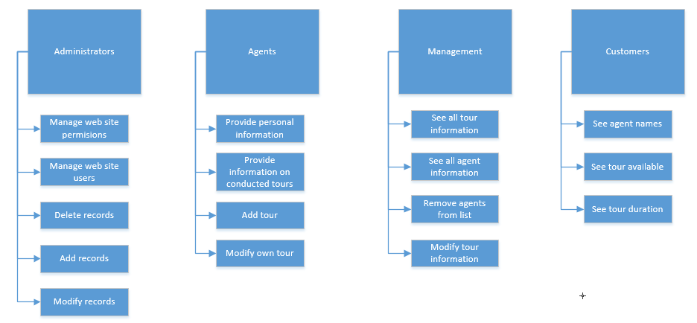

## **Database Investigation**

**We investigated three Database management systems.**

The amazon Relational Database Service it is easy to set up and operate. Makes it easy to go from project conception to deployment.

You can have two storage options: one optimized for high-performance applications, and the other for cost-effective general-purpose use.

Also, easy to control network access to your database and it is not very expensive.

Zoho Creator is easy to organize and process data. Zoho is user-friendly and helps you build online databases from zero. The user can drag and drop fields to build forms or applications based. Also you can analyze details using the reports and dashboards created by Zoro. But unfortunately, is not so cheap.

We choose SQLLite for our Database management Systems because it is open source database engine used by applications because of compact size, cross platform stability and serverless functionality.

Allows us to setup and test all our database structures, it's quick and easy to use and does not use much of storage space.

As we are building a web site for a mid-level organization the SQLLite is affordable and fits the purpose.

Security Design

# **Framework Security**

The web framework used for this web application is Django, it has effective protections build-in against several common threats, including XSS and CSRF attacks and many other problems. It allows rapid, secure and agile web development, with better applications in less time.

The Security Features we are using for the web application are:

User Management

Django Admin

Authorization

Cookies

SQL Injections

Files

Data Validation

Password Storage

# **Security Mechanisms**

### Authentication: Password must use a combination of upper- and lower-case letters, numbers, and punctuation/special characters, such as &^$#. Also, the user has only 3 attempts to login if not successful the user account gets locked and only the person with the administration credentials can unlock the account.

### Usernames and password must follow the guideline documentation and if it is possible implement Two-factor authentication to increase login security.

### For security reasons the account must be locked, or the password can be reset using the phone number that user has stored in the database, so the administrator must call the user back to reset password or unlock account. The administrator is not able to send password by emails.

### The web application host with features like web application firewall (WAF) and denial-of-service (DDoS) protection to ensure you will build a safe website.

### A good and friendly content management system (CMS) as it is a [useful tool to construct web application](https://www.webfx.com/cms.htm) and manage future content, keep in mind the most beneficial ones are continually advancing their protections.

### The web application has some add-on and plugin but with Periodic inspection to reduce the likelihood of defective extras. Also, we can use add-ons for our benefit like the ones that limit viruses.

### Restrict users and employees' permissions for specific areas of the website to prevent error and crashes.

### Automatic backups are Set up to keep the application safe, it can keep you from starting from scratch.

**User Roles and Permissions**

* Administrators – look after the web site. They should have permissions to add, modify and delete records from all the tables and manage website users and permissions
* Agents – they provide their personal information and information on the tours they conduct. They should have permissions to add a tour and modify tours that they conduct. Note: Agents should only be able to modify their own tours.
* Management – They should be able to see all the tour and agent information. They should also be able to remove agents from the list and modify all the tour information.
* Customer– They should be able to book a tour.
* Visitor – Should only be able to view the website.

# User Interface Design

Overall site map will need to include the following pages:

· Home

· About

· Tour details page

· Agent detail page

**User Story #1: As a customer...**

...I would like to be able to use the web application from multiple devices.

...I would like to be able to see the agent details.

...I would like to be able to see tour available.

...I would like to be able to see tour duration.

...I would to be able to book a tour.

For the first release, this will be performed by customers. The views required are:

· Create user account

· Access web application from multiple devices

· Book tour online

**User Story #2: As an Administrative shareholder...**

...I would like to have control over the web site.

For the first release, this will be performed by administrative shareholders. The views required are:

· Add records from all the tables

· Modify records from all the tables

· Delete records from all the tables

· Manage website

· Manage users

· Manage permissions

# UI Design

**Web application overall look:**

For the web application background colors, we used light grey, dark gray and white.

For the web application fonts colors, we used grey, white and light blue.

For the Font we used Calibre font.

The web applications have a simple and clean look.

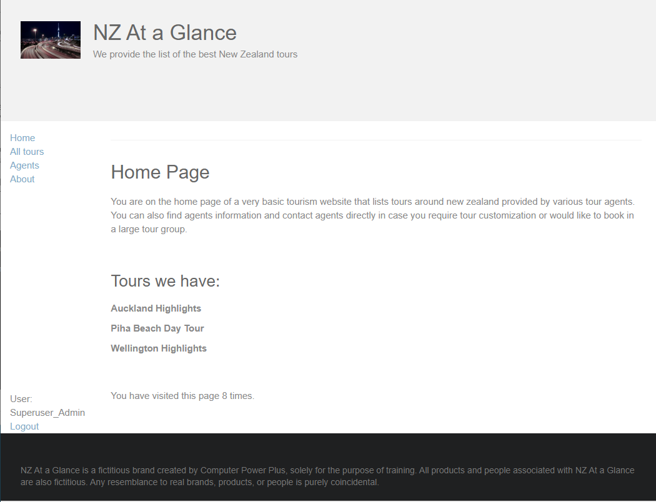

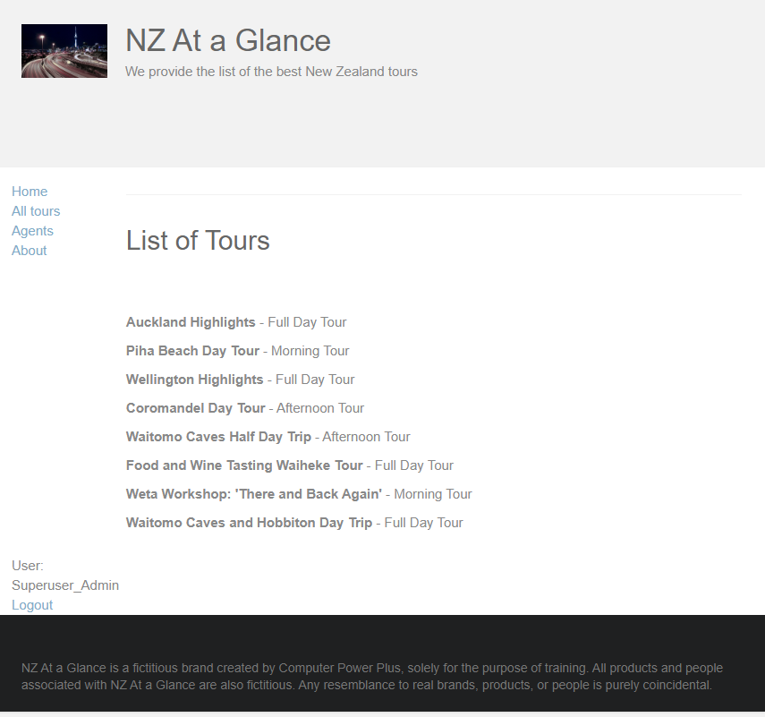

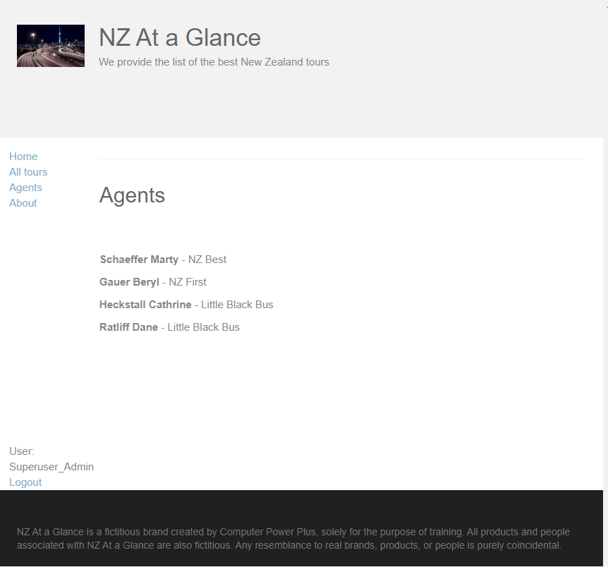

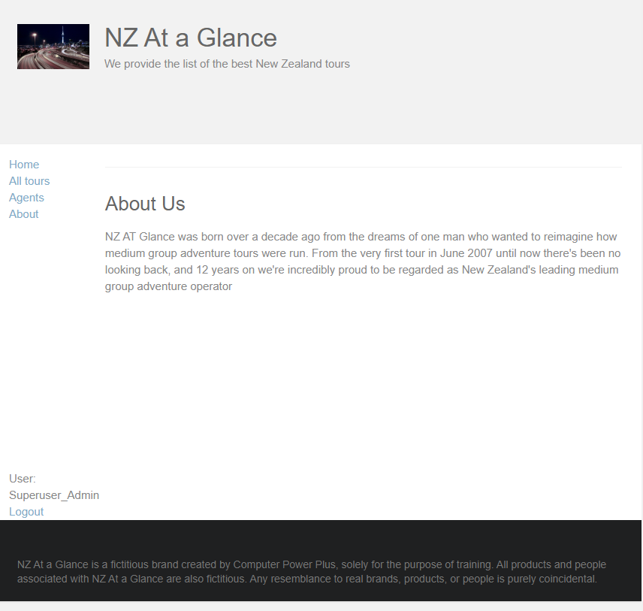

**Wireframe for NZ AT a Glance web application:**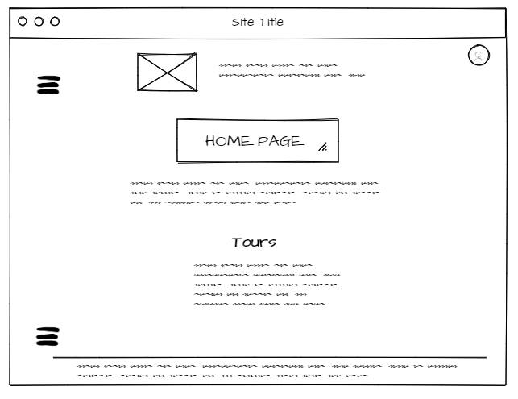

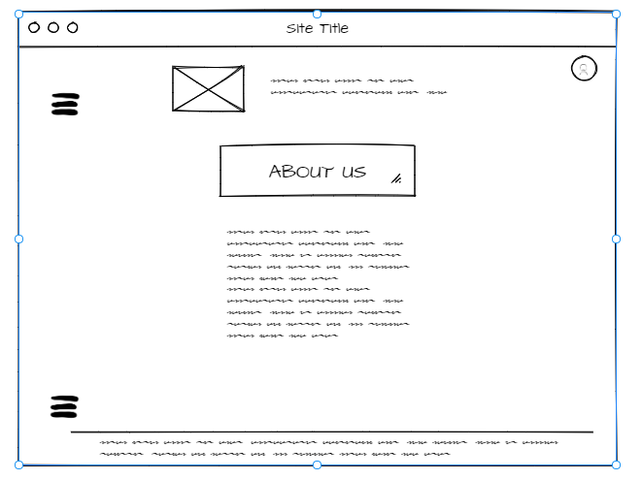

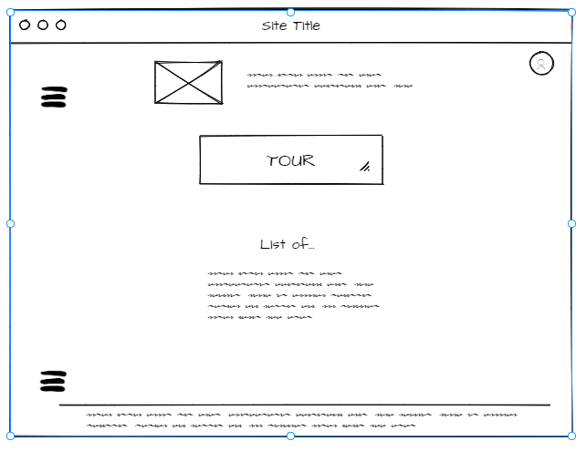

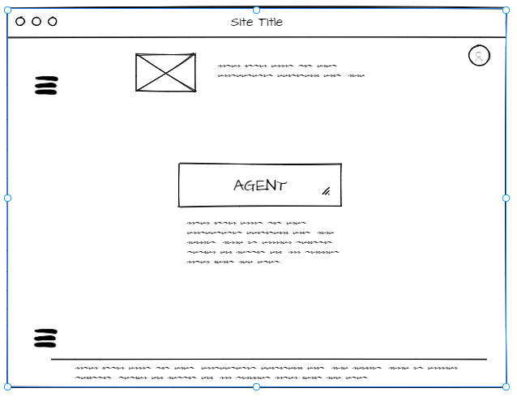

**Task 5: Implementation and Testing**

Implementation are completed and tested.

**Test Log:**

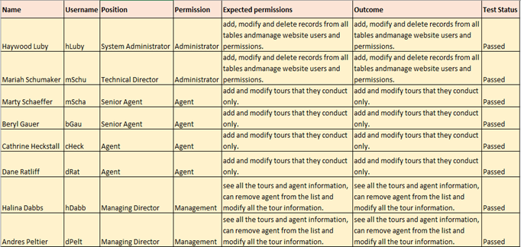

**Team Process Review outcome:**

Review each other work (worker harder to meet requirements) …....

**Task 6: Peer Evaluation & Final Reflection**

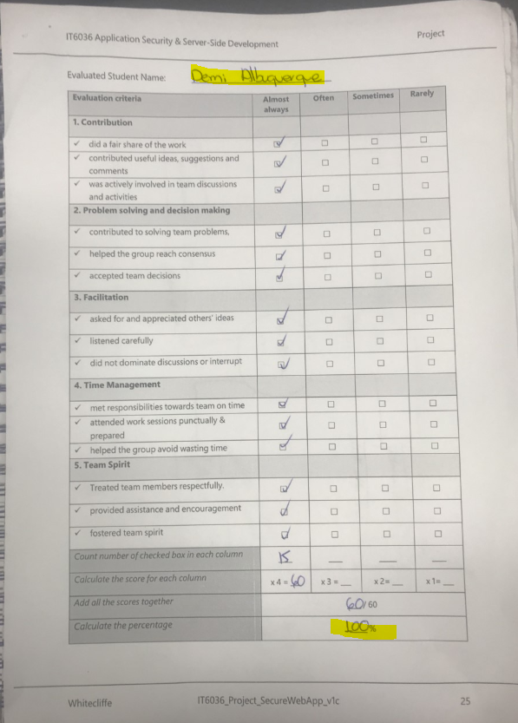

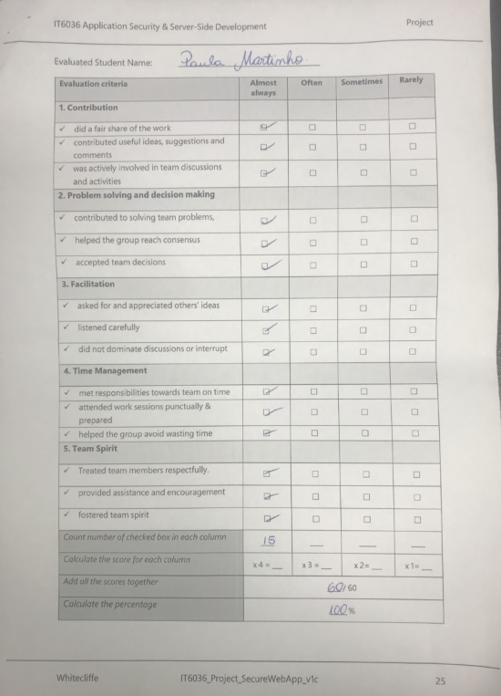

**Evidences of Team Communication**

**Meeting Minutes:**

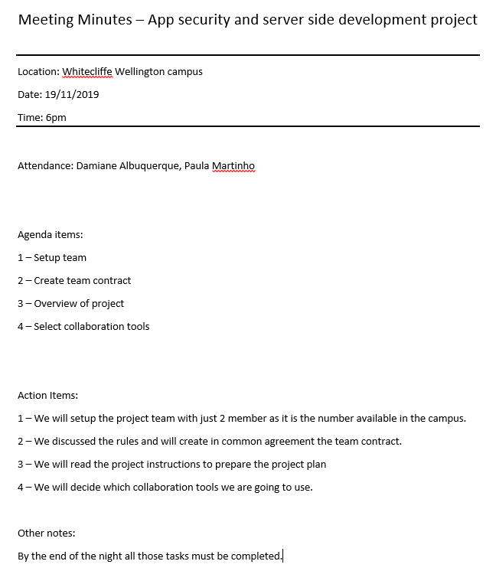

--------------------------------------------------------------------------------------------

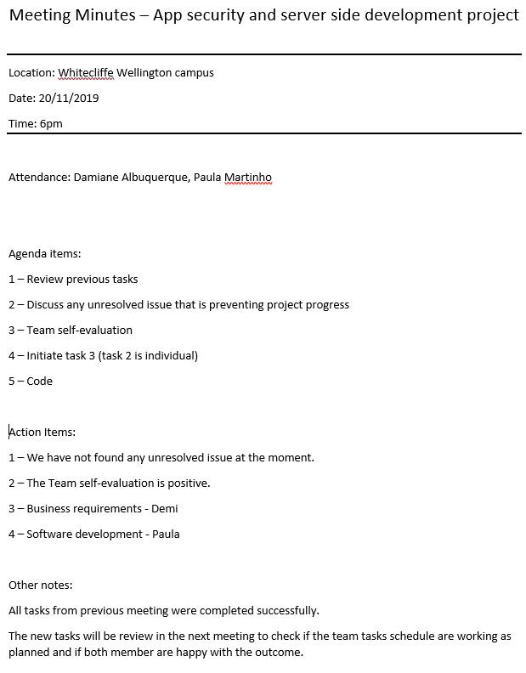

--------------------------------------------------------------------------------------------

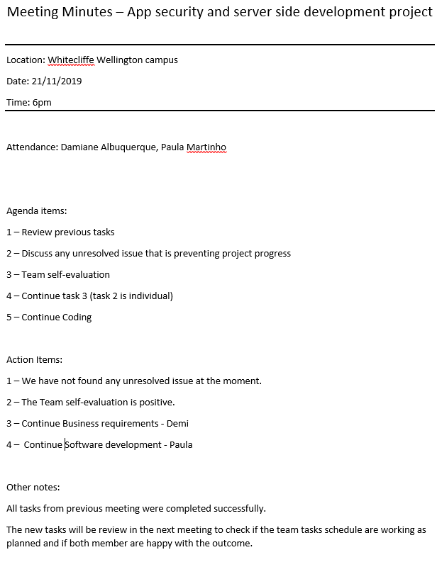

--------------------------------------------------------------------------------------------

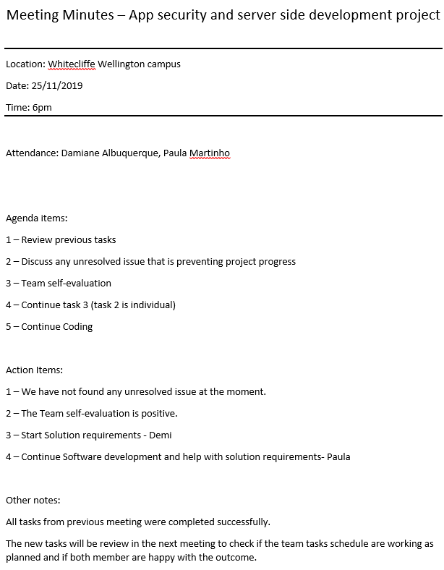

--------------------------------------------------------------------------------------------

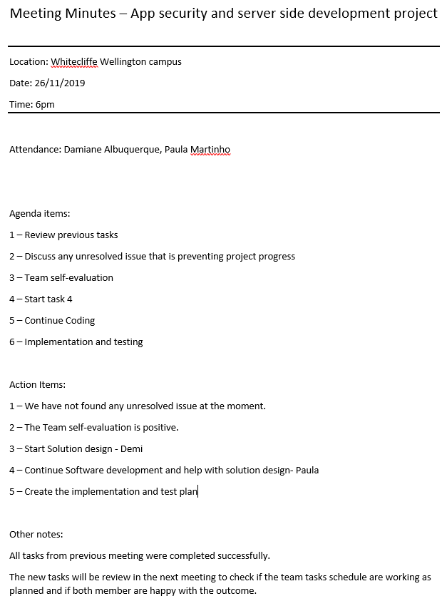

--------------------------------------------------------------------------------------------

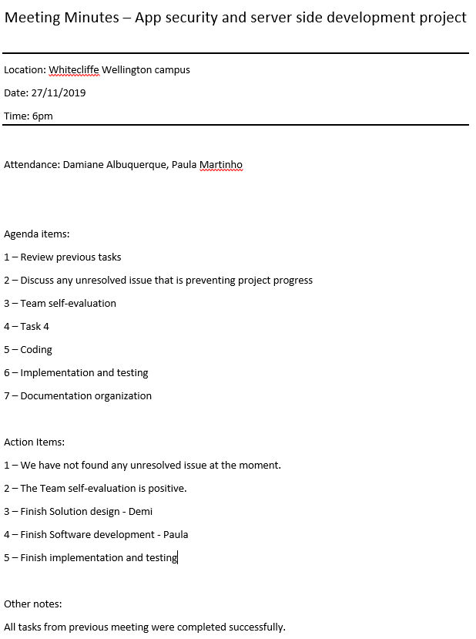

**Evidence of office 365 tool used by the team for the project management and task delegation**

**- Planner**

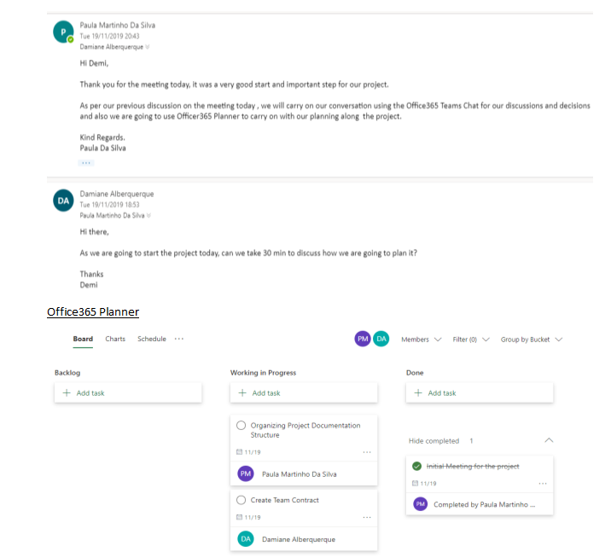

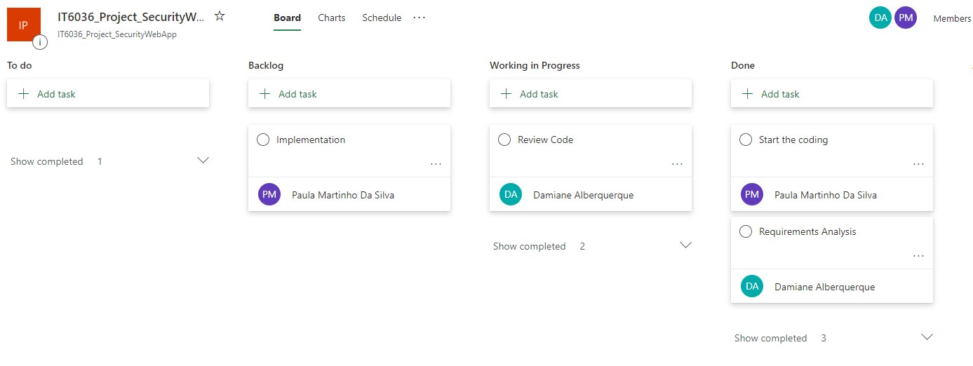

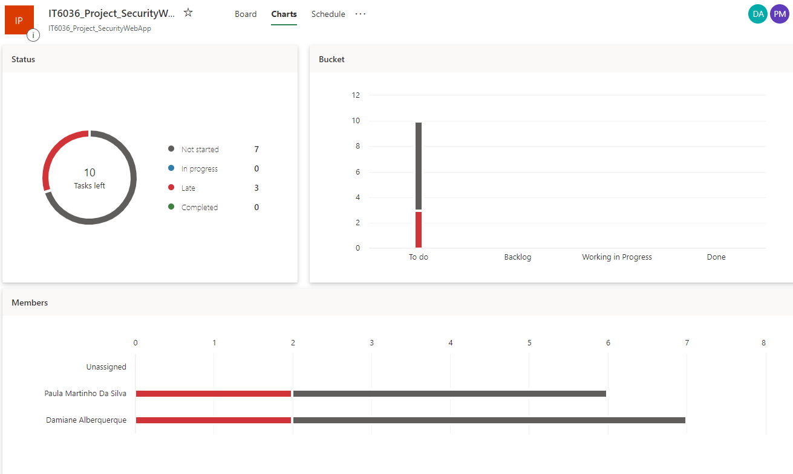

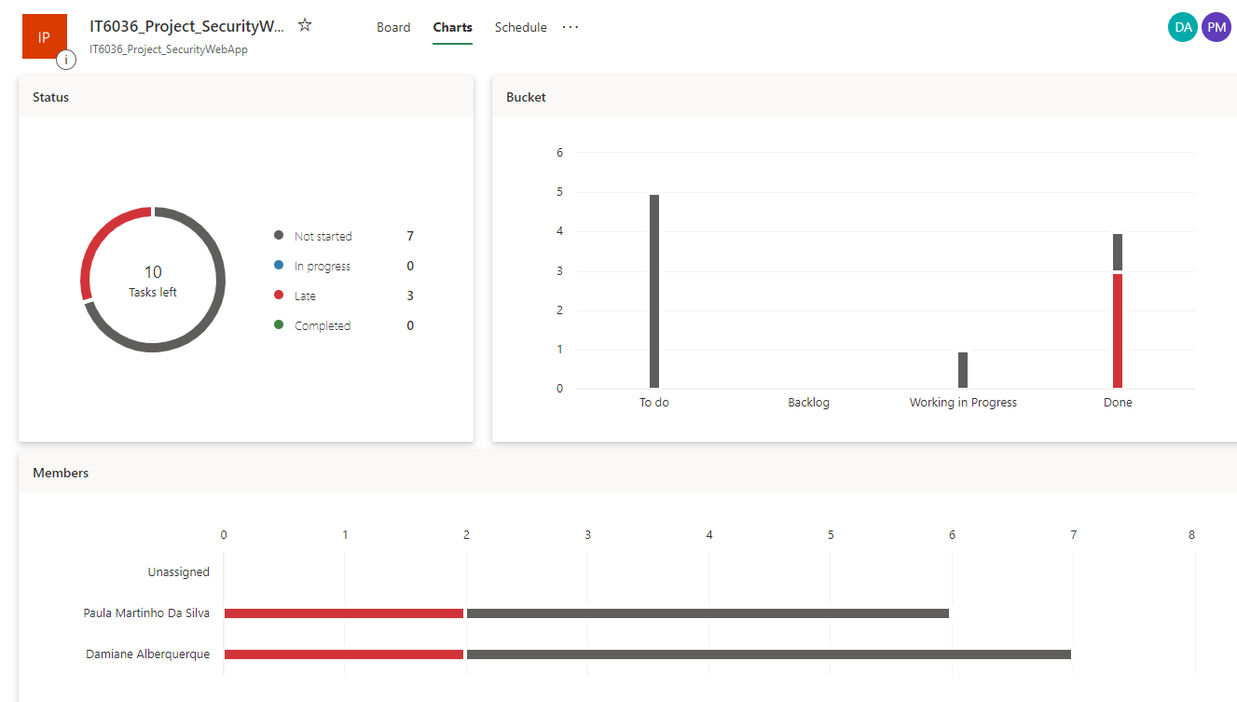

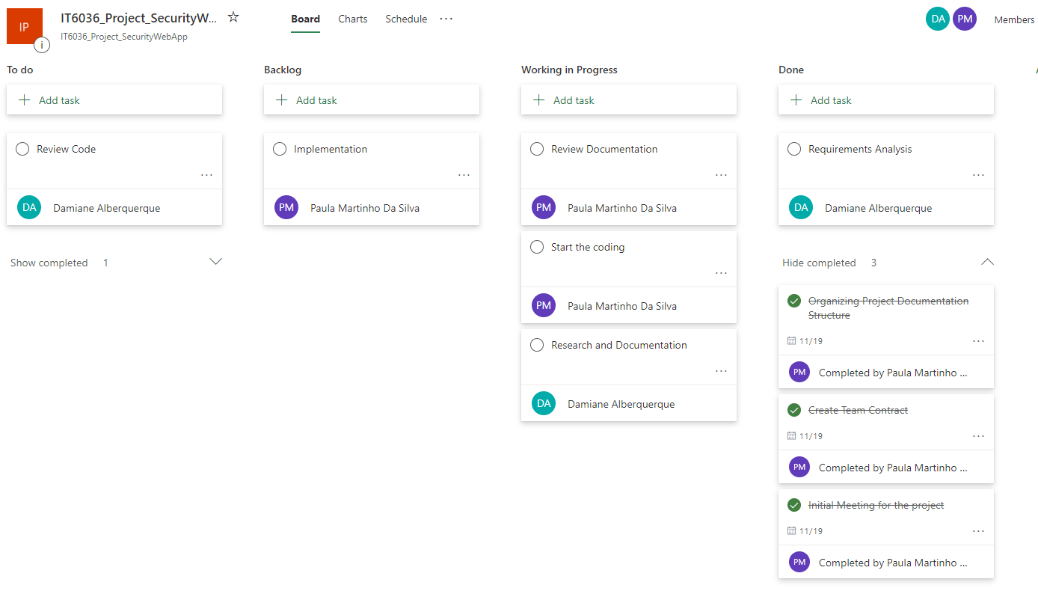

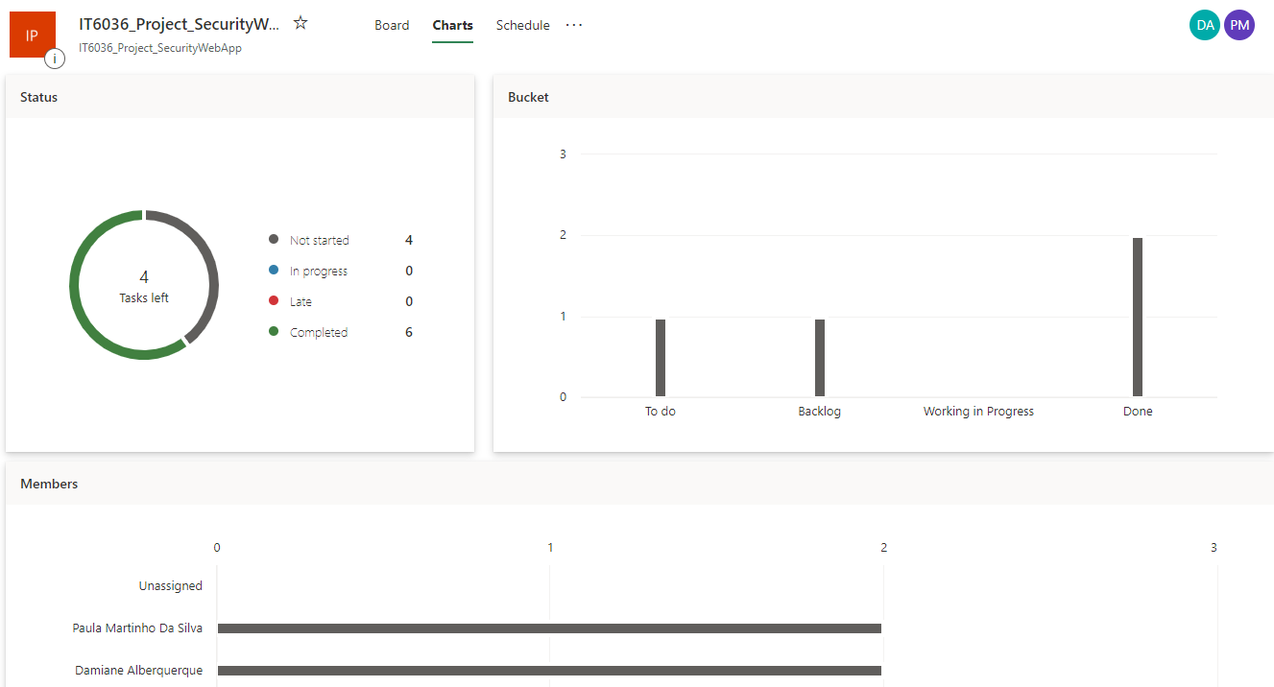

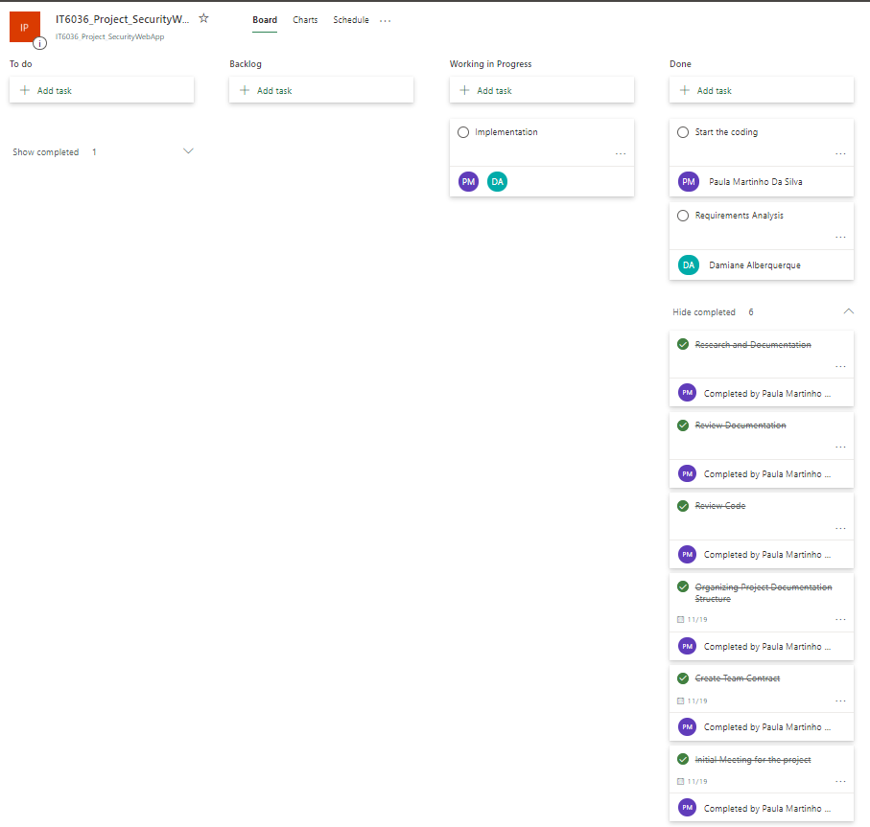

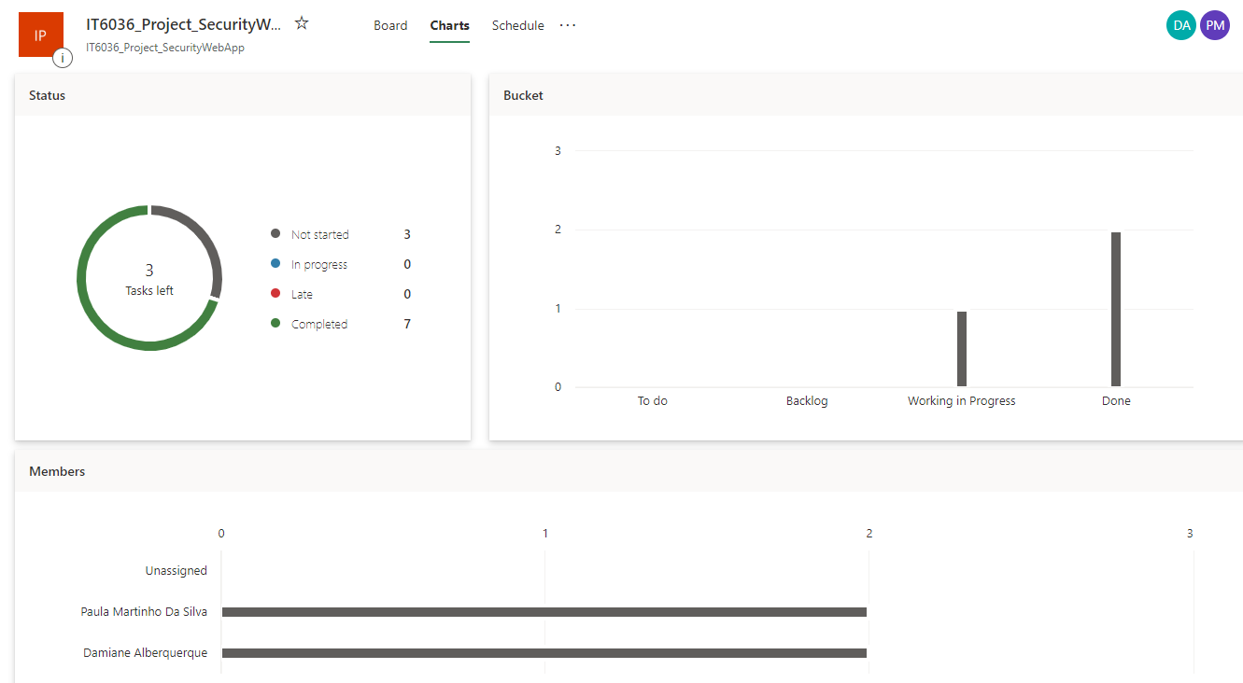

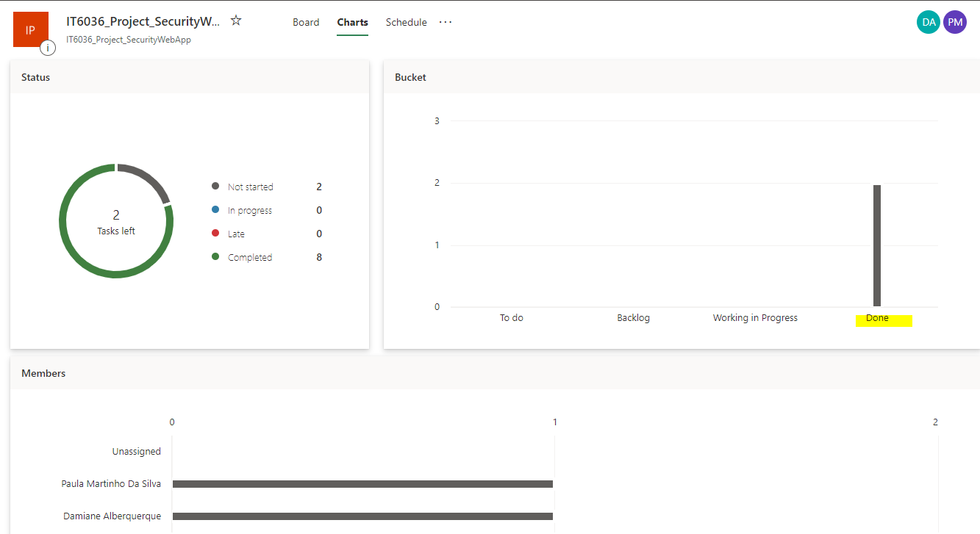

**Evidence of office 365 quick decision and update tool used by the team**

**– Office 365 Chat (instantaneity message)**

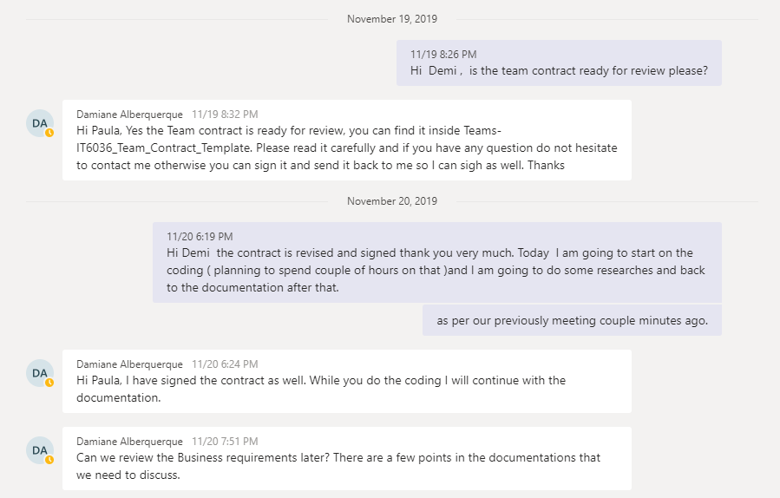

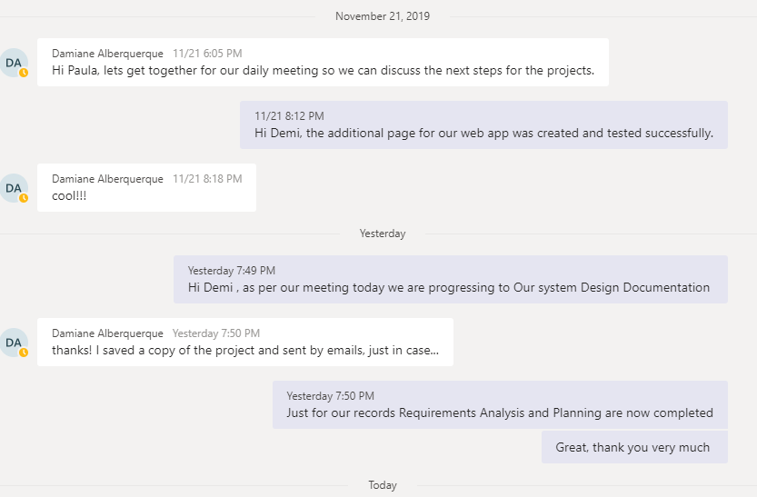

**Team Evaluation**

Team Process Self-Evaluation

